Stationery House

By

Honey

Level-6

Final Project

Table of Contents

Project Proposal 3

Goals and Objectives 3

Project Scope 3

Project Specifications 3

Target Audience 3

Project Deliverables 4

Resource Requirements 4

Project Tasks and Milestones 4

Project Assumptions 5

Project Report 5

Detail Design 6

Home Page 6

Registration Page 6

Login Page 7

All Categories Admin View 7

All Stationery Admin View 8

All Categories Visitor View 8

All Stationery Visitor View 9

Place Order Visitor View 9

Project Testing 10

User Manual 10

Summary 10

System Configuration 10

User Access Levels 10

# 

# Project Proposal

## Goals and Objectives

The main goal or aim of the project is to implement an online web application named “Stationery House”. The main purpose of the application is help people to find their daily requirement of Stationery Items in easy manner and place their bulk order. In this application there are two types of users- admin and registered visitor. Admin has different functionalities as compare to registered visitor. Admin can add, edit, delete and check details of all categories, all subcategories and stationery items. Admin can delete and check details of the order place by registered user.

## Project Scope

The scope of this project is to implement an app named “Stationery House” with the help of which registered or visitor user can find any available stationery details as well as option to place order. The duration of the project is 20 working days which is equals to 4 weeks.

## Project Specifications

* Admin login/logout
* Add, edit, delete and check details of categories added by admin user.
* Admin can delete, edit and check subcategories details.
* Admin can delete and check stationery item details.
* Admin can register new admins.
* Registered Visitor can login/logout.
* New Visitor can register.
* Registered Visitor can place their order of stationery items.

## Target Audience

The target audience for this project is the people who love to use stationery items and view their details. The age can go from 5 plus to 100 plus.

## Project Deliverables

The deliverables of the project are:

|  |  |
| --- | --- |
| Deliverable | Description |
| Final Report | This will be the final report of the project. |
| Coding | The executable code of the project will go under this. |
| Documentation | This portrays the documentation of the project. |
| Testing | All the test details will be covered in this part. |

## Resource Requirements

* Windows Operating System.
* Microsoft word for documentation.
* Asp.net MVC Framework
* 64-bit Processor and 4 GB or more RAM
* Identity framework- ASP

## Project Tasks and Milestones

|  |  |  |  |  |
| --- | --- | --- | --- | --- |
| **Tasks** | **Week-1** | **Week-2** | **Week-3** | **Week-4** |
| Brainstorming and analysis |  |  |  |  |
| Planning and initial meeting Project Proposal document. |  |  |  |  |
| Database Design and UI Design |  |  |  |  |
| Identity framework implementation |  |  |  |  |
| Coding for admin and reporter |  |  |  |  |
| Testing |  |  |  |  |
| Final Documentation and closing |  |  |  |  |

## Project Assumptions

Following are the assumption made while implementing the project:

* One admin and registered visitor will be registered by default.
* Application will be free and open source.

# Project Report

#### Functional and Non-Functional

|  |  |
| --- | --- |
| Users | Functional |
| Admin | * Login/logout * Register new admins * Admin can add, edit, delete, check details for categories. * Admin can edit, delete and check details for sub categories details. * Admin can delete and check details for the stationery items. |
| Customer | * Can view details of categories and their subcategories with stationery details * Can place their order based upon their selection of stationery * New customers can register for free. * Login using valid credentials |
|  | Non- Functional |
|  | * High speed * Fast Loading time * High performance and security * All browsers compatibility. |

## Detail Design

### Home Page

The main landing page of the application. On navigation bar options are- Home, All Categories, All Stationery, Register, Login.

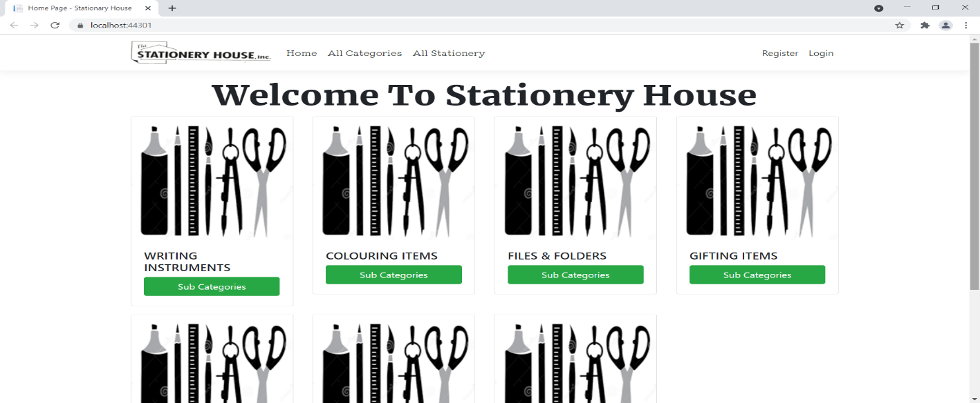

### 

### Registration Page

With the help of this page, new registered visitor can sign up for the app

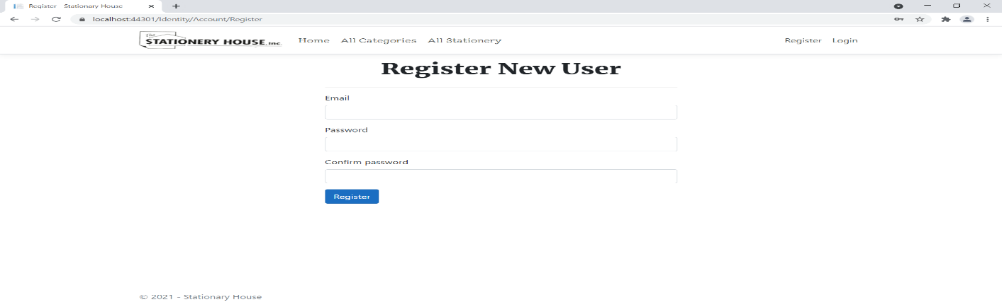

### 

### Login Page

With the help of this page, registered visitor and admin can login to the application using their valid credentials.

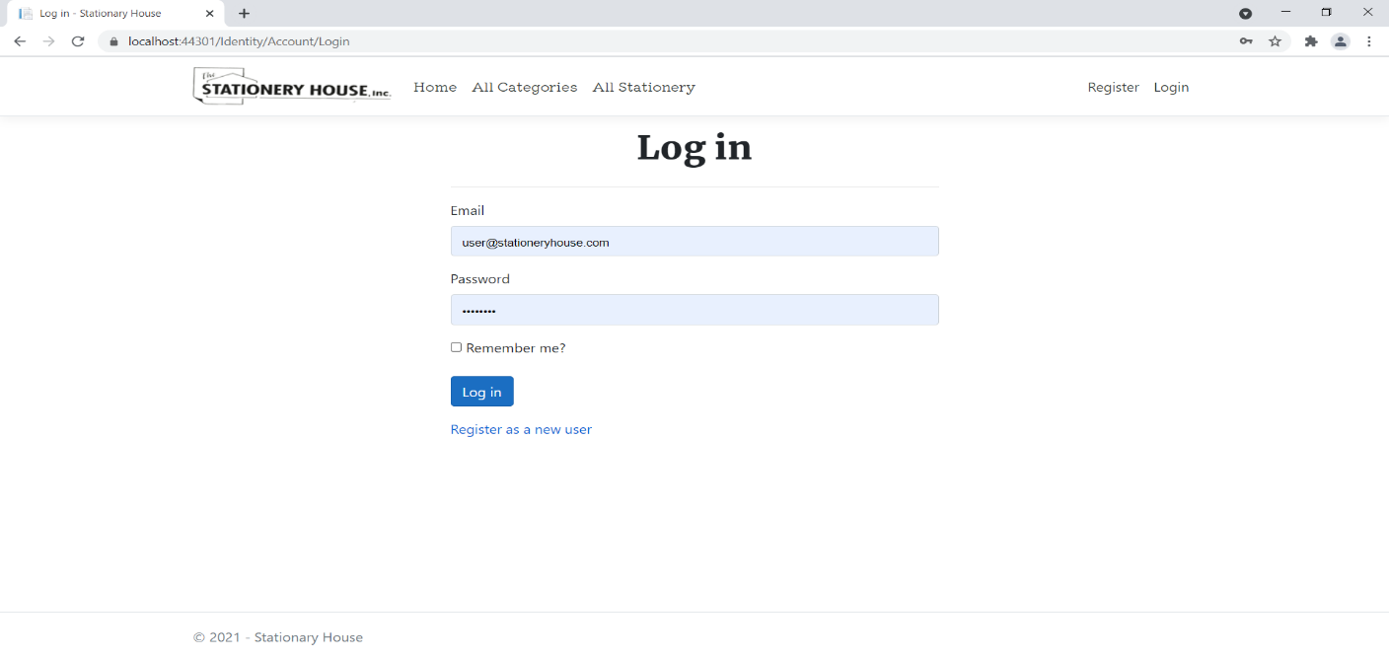

### 

### All Categories Admin View

This page highlights all the categories available on the application. Admin can delete and check details of the existing ones.

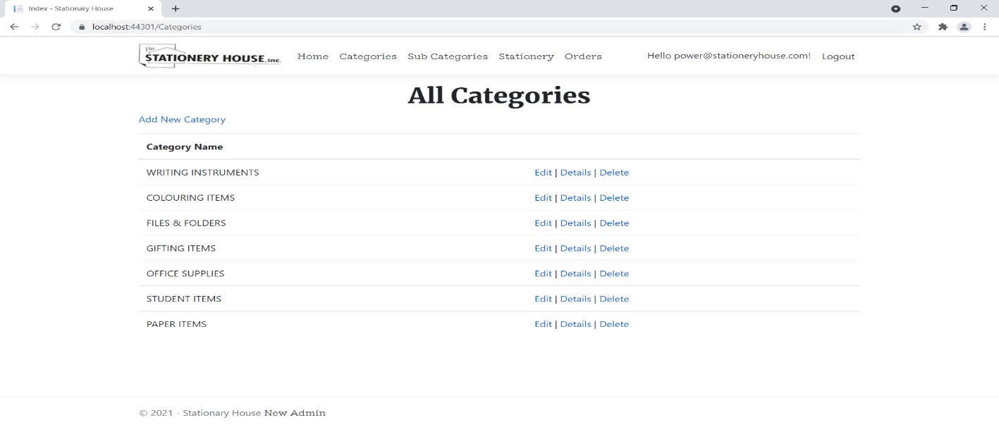

### All Stationery Admin View

With the help of this page admin can manage the stationery details by editing, deleting and checking their details.

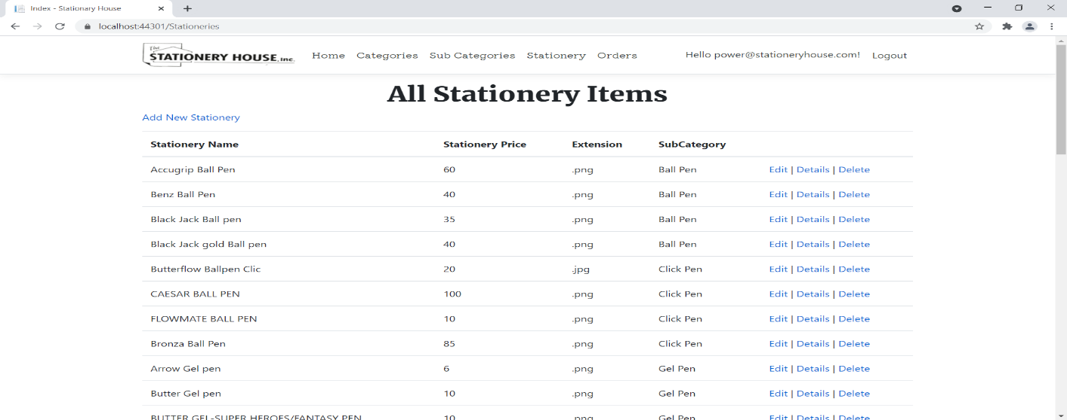

### 

### All Categories Visitor View

With the help of this page Visitor can view All Category and Sub Category details.

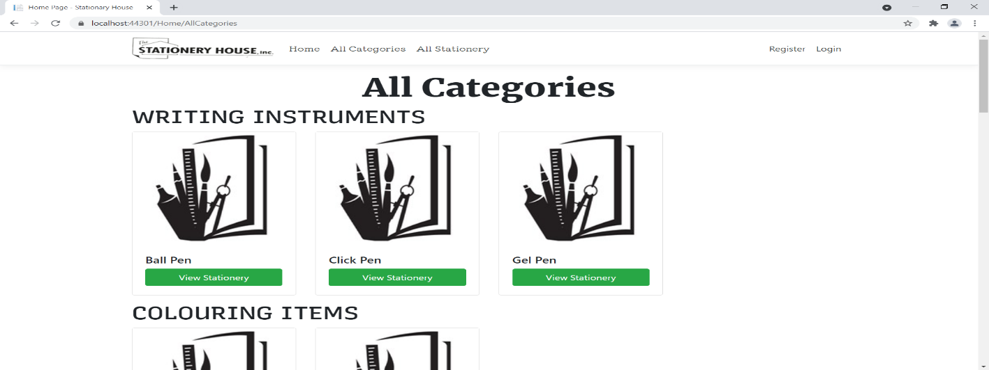

### 

### All Stationery Visitor View

With the help of this page visitor can check the details of the Stationery and link to their Place Order.

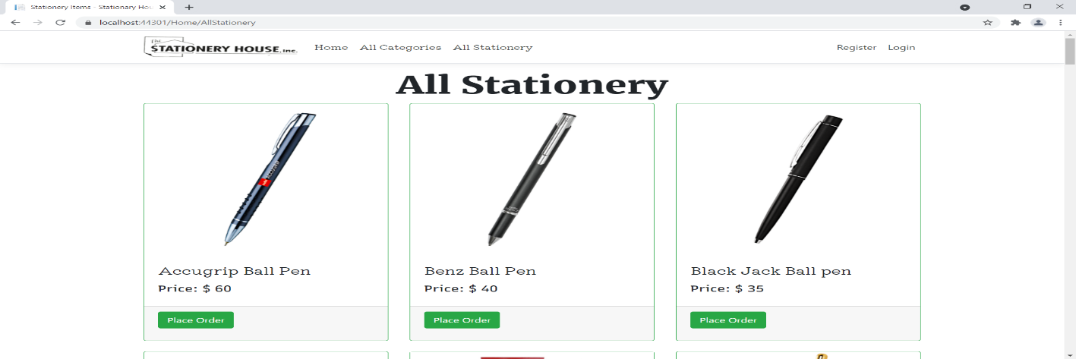

### Place Order Page Customer View

This page shows the Place Order of a particular Stationery Item after successful login.

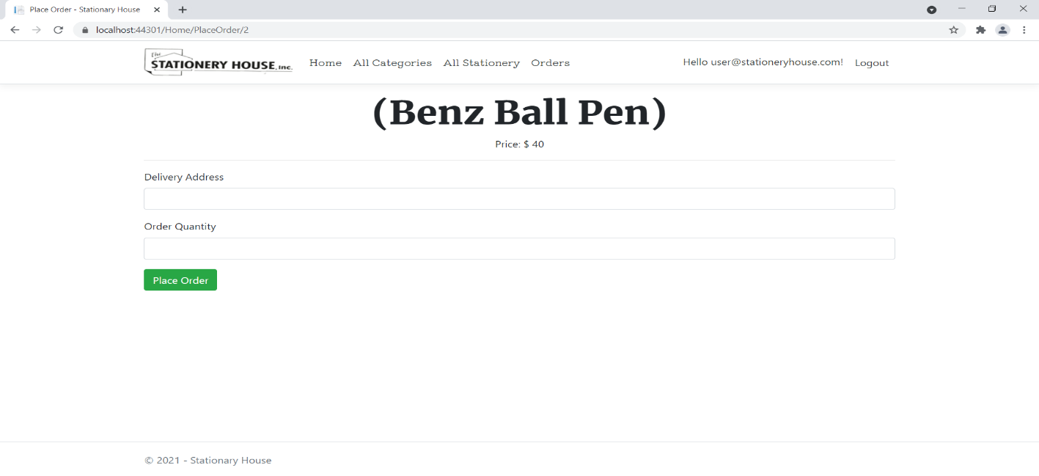

## 

## Project Testing

The testing file for usability testing is attached as [usability test.xlsx](usability%20test.xlsx)

# User Manual

The main purpose of the application Stationer House Web Application is to help people to find stationery details and provide a way to place order of these items. In this application there are two types of users- admin and registered user or visitor customer. Admin has different functionalities as compare to customers. Admin can add, edit, delete and check details of categories, subcategories, and stationery entries. Also, admin can delete and check the order place by registered user.

## Summary

### System Configuration

This app will be useful to for distributing mobile information in presentable format.

### User Access Levels

Only registered users can access the features of this application.

* **Admin:** Admin has full access of the app can register new admins.
* **Registered Visitor:** New visitor can register and existing can login using their own credentials. They have limited access.